  - Christal Chen, SiFirst Internship 2026

SPI Interface Report
Table of Contents
Introduction 2
Project Objective 2
Supported Features 2
System Architecture 2
Slave Design 3
FSM Diagram 3
Block Diagrams 3
Register Descriptions 4
Signal Descriptions 4
Master Design 6
FSM Diagram 6
Block Diagrams 6
Register Descriptions 7
Signal Descriptions 7
Transaction Flow 9
Write Operation Sequence 9
Read Operation Sequence 10
SPI Mode (CPOL/CPHA) Operation 11
Verification 12
Testbench Architecture 12
Waveform Examples 13
Conclusion 14

Introduction

Project Objective
The goal of this learning project was to gain hands-on experience with RTL design and develop a practical understanding of the SPI communication protocol by designing, implementing, and verifying a synthesizable SPI master and slave interface.

Supported Features
The 4-wire SPI interface supports all four standard SPI modes (Modes 0–3) using configurable clock polarity (CPOL) and clock phase (CPHA), along with a programmable clock divider. It supports both read and write operations with up to 32 bits (4 bytes) of data transferred in a single transaction.
SPI Operational Features (Source: ICM-42602)
- Data is delivered MSB first and LSB last.
- ﻿SPI read and write operations are completed in 16 or more clock cycles (two or more bytes). The first byte contains the SPI Address, and the following byte(s) contain(s) the SPI data. The first bit of the first byte contains the Read/Write bit and indicates the Read (1) or Write (0) operation. The following 7 bits contain the Register Address. In cases of multiple-byte Read/Writes, data is two or more bytes.

System Architecture

Slave Design

FSM Diagram

Block Diagrams
Overview | Controller
Datapath

Register Descriptions
Register | Width | Reset Value | Description
s_state | 3 | IDLE | Current state of the slave FSM.
s_next_state | 3 | IDLE | Next-state value generated by the controller FSM.
s_sample_shift | 8 | 0x00 | Shift register that serially receives address and write data from the MOSI line.
s_drive_shift | 8 | 0x00 | Shift register that serially transmits register data on the MISO line during read transactions.
s_bit_cnt | 4 | 0 | Counts the number of bits transferred within a byte and generates the byte completion status.
s_r_addr | 7 | 0x00 | Read address presented to the register file during read operations.
s_transfer_addr | 7 | 0x00 | Tracks the current register address during multi-byte read transactions. Automatically increments after each byte transferred.
s_w_addr | 7 | 0x00 | Write address presented to the register file during write operations. Automatically increments after each received byte.
s_rw | 1 | 0 | Stores the read/write command captured from the first bit of the address byte (1 = Read, 0 = Write).
s_miso | 1 | 0 | Serial data output driven onto the SPI MISO line during read transactions.

Signal Descriptions

Internal Signal Descriptions
Signal | Width | Type | Description
s_byte_done | 1 | Status | Asserted when eight bits have been transferred, indicating completion of one byte.
s_addr_valid | 1 | Status | Indicates whether the current register address is within the valid register file address range.
s_w_en | 1 | Control | Enables writing the received byte into the register file during write transactions.
s_miso_sel | 1 | Control | Enables the slave to drive the MISO output during read transactions.
s_drive_shift_load | 1 | Control | Loads register file read data into the transmit shift register at the start of a read transaction and after each completed byte.
s_sclk_in | 1 | Timing | Internal SPI clock adjusted according to the selected CPOL and CPHA configuration. Used as the internal sampling clock for the slave datapath.
s_r_data | 8 | Data | Data read from the register file and loaded into the transmit shift register during read operations.

Input Port Descriptions
Port | Width | Description
s_rst | 1 | Active-high asynchronous reset.
s_cpol | 1 | SPI clock polarity selection.
s_cpha | 1 | SPI clock phase selection.
s_sclk | 1 | SPI serial clock received from the master.
s_cs | 1 | Active-low chip-select input. Initiates and terminates SPI transactions.
s_mosi | 1 | Serial data input received from the SPI master.

Output Port Descriptions
Port | Width | Description
s_miso | 1 | Serial data output transmitted from the slave to the SPI master during read operations.

Register File Interface Signals
Signal | Width | Direction | Description
rf_clk | 1 | Input | Register file clock (s_sclk).
rf_rst | 1 | Input | Register file reset.
rf_r_addr | 7 | Input | Address of the register to be read.
rf_w_addr | 7 | Input | Address of the register to be written.
rf_w_data | 8 | Input | Data written into the register file during write transactions.
rf_w_en | 1 | Input | Register file write enable.
rf_r_data | 8 | Output | Data read from the addressed register.

Master Design

FSM Diagram

Block Diagrams
Overview | Controller
Datapath

Register Descriptions
Register | Width | Reset Value | Description
m_state | 3 | IDLE | Current state of the master FSM.
m_next_state | 3 | IDLE | Next-state value generated by the controller FSM.
m_sample_shift | 8 | 0x00 | Shift register used to serially receive data from the MISO line. One bit is sampled on each latch edge.
m_drive_shift | 8 | 0x00 | Shift register used to serially transmit address and write data through MOSI.
m_r_data | 32 | 0x00000000 | Receive data register that stores bytes collected during SPI read transactions.
m_w_data_rem | 32 | 0x00000000 | Holds the remaining write data to be transmitted. One byte is removed after each completed byte transfer.
m_bit_cnt | 4 | 0 (or 1 when CPHA = 0) | Counts transmitted or received bits within a byte. Generates the byte completion status.
m_data_rem | 4 | 0 | Tracks the number of data bytes remaining in the current SPI transaction.
m_clk_cnt | 3 | 1 | Clock divider counter used to generate the SPI serial clock from the host clock.
m_sclk_in | 1 | 0 | Internal serial clock before CPOL adjustment.
m_sclk_prev | 1 | 0 | Delayed version of the serial clock used for edge detection.
m_sclk | 1 | CPOL | SPI serial clock output. Driven according to CPOL and clock divider.
m_cs | 1 | 1 | Chip-select output. Asserted low during an active SPI transaction.
m_mosi | 1 | 0 | Master Out Slave In serial data output.

Signal Descriptions

Internal Signal Descriptions
Signal | Width | Type | Description
m_byte_done | 1 | Status | Asserted when eight bits have been transferred, indicating completion of one byte.
m_transfer_done | 1 | Status | Asserted when all requested bytes have been transferred. Used by the FSM to terminate a transaction.
m_drive_shift_addr | 1 | Control | Loads the address byte (RW + Address) into the transmit shift register at the beginning of a transaction.
m_drive_shift_write | 1 | Control | Loads the next write-data byte into the transmit shift register after each completed byte.
m_falling_edge | 1 | Timing | Indicates detection of a falling edge on the generated SPI clock.
m_rising_edge | 1 | Timing | Indicates detection of a rising edge on the generated SPI clock.
m_latch_en | 1 | Timing | Enables sampling of incoming serial data based on the selected SPI mode (CPOL/CPHA).
m_cnt_en | 1 | Timing | Enables transmit shift register updates and bit counter increments on the appropriate SPI clock edge.

Input Port Descriptions
Port | Width | Description
m_hclk | 1 | System clock used by the SPI master logic.
m_rst | 1 | Active-high asynchronous reset.
m_en | 1 | Starts a new SPI transaction when asserted.
m_rw | 1 | Transaction type. 1 = Read, 0 = Write.
m_addr | 7 | Register or memory address sent during the address phase.
m_w_data | 32 | Parallel write data provided by the host.
m_transfer_len | 4 | Number of bytes to transfer after the address phase.
m_clk_div_val | 3 | Clock divider value used to generate the SPI serial clock.
m_cpol | 1 | Clock polarity selection.
m_cpha | 1 | Clock phase selection.
m_miso | 1 | Serial data input from the SPI slave.

Output Port Descriptions
Port | Width | Description
m_sclk | 1 | Generated SPI serial clock.
m_cs | 1 | Active-low chip-select output for the SPI slave.
m_mosi | 1 | Serial data transmitted from the master to the slave.

Transaction Flow

Write Operation Sequence

Mode 3 Write protocol (Source: LSM6DSO)
Single byte: | 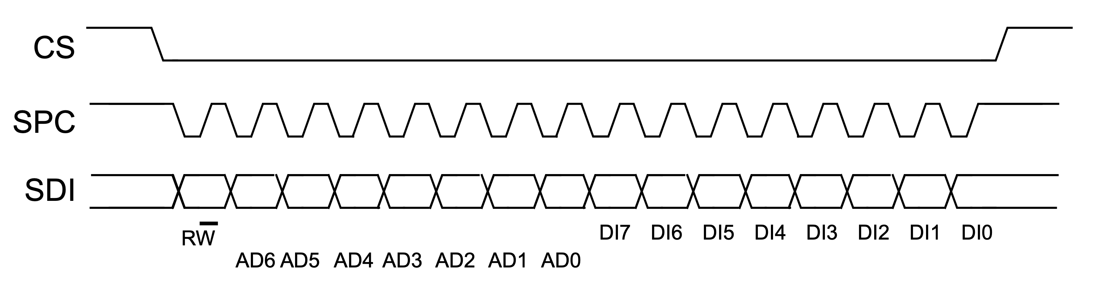
Multi byte: | 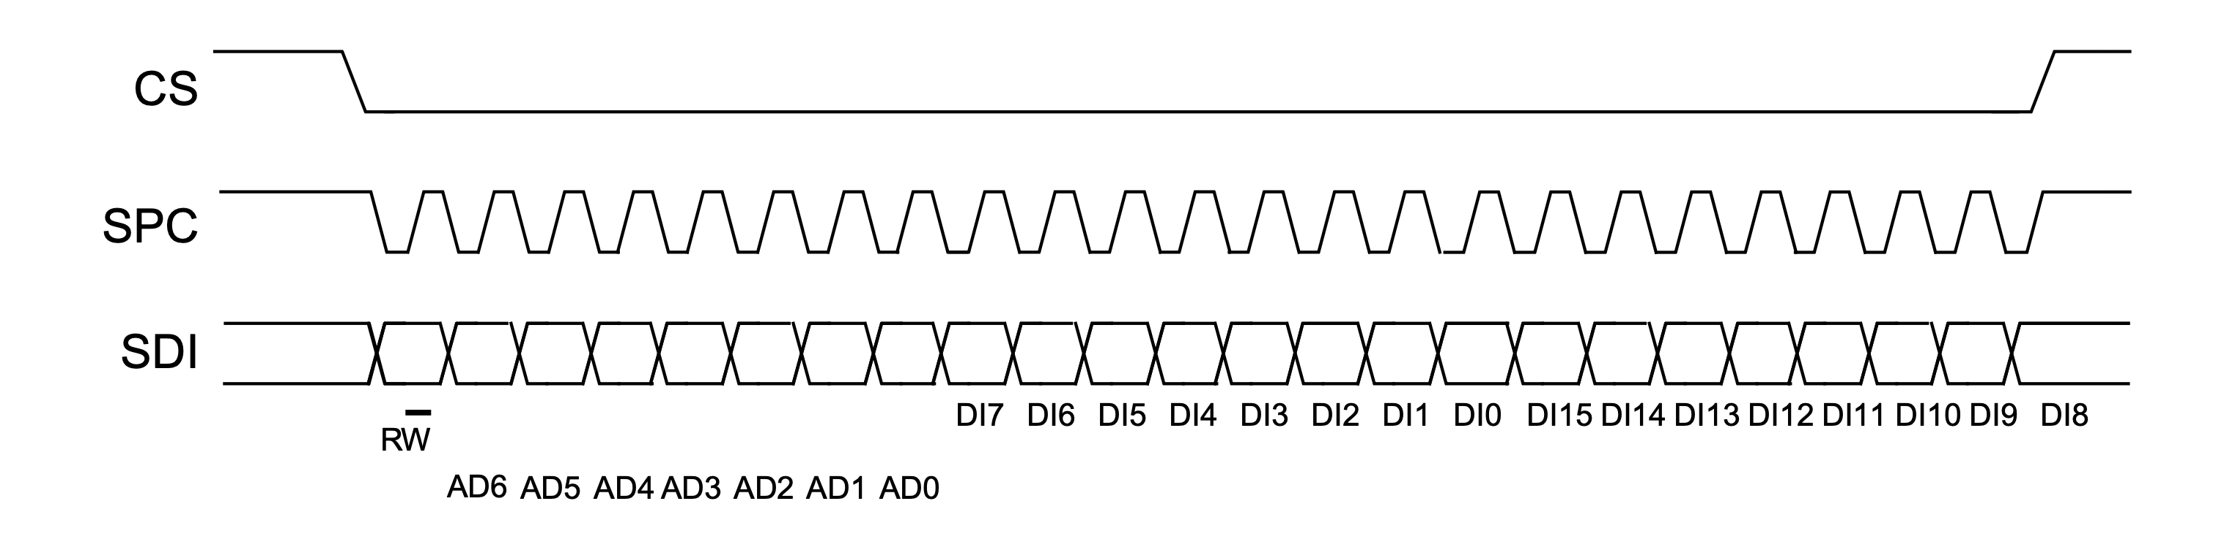

Read Operation Sequence

Mode 3 Read protocol (Source: LSM6DSO)
Single byte: | 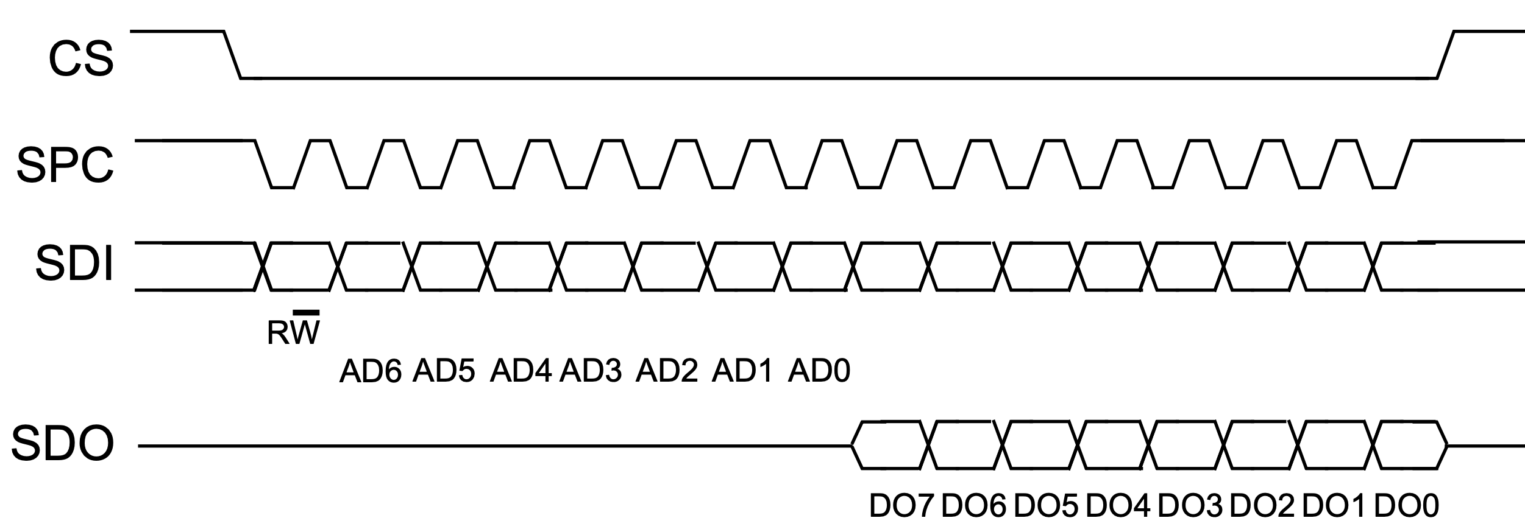
Multi byte: | 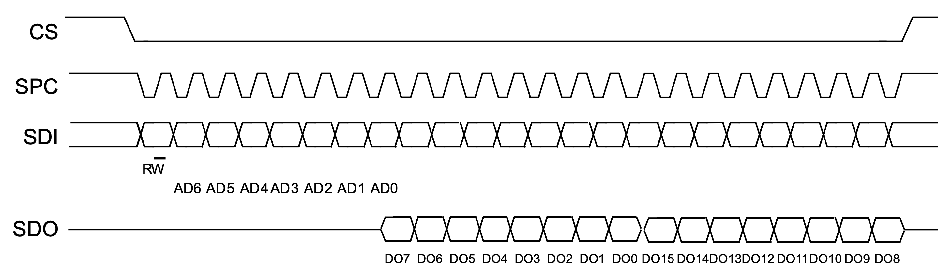

SPI Mode (CPOL/CPHA) Operation
The SPI master and slave support all four standard SPI modes through configurable clock polarity (CPOL) and clock phase (CPHA). In the Master module, the design generates the appropriate sampling (latch_en) and shifting (cnt_en) signals by combining CPOL and CPHA with edge detection logic. This allows the same datapath and controller to operate correctly under all four SPI modes.
SPI Mode | CPOL | CPHA | Idle Clock | Data Sampled On | Data Shifted On
Mode 0 | 0 | 0 | Low | Rising Edge | Falling Edge
Mode 1 | 0 | 1 | Low | Falling Edge | Rising Edge
Mode 2 | 1 | 0 | High | Falling Edge | Rising Edge
Mode 3 | 1 | 1 | High | Rising Edge | Falling Edge

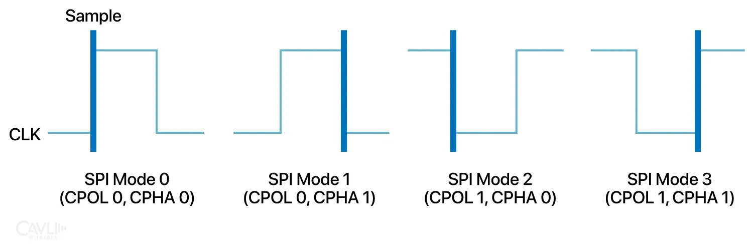(Source: Calvi Wireless)

Verification

Testbench Architecture
- Instantiates the SPI system (master and slave).  - Generates the system clock and reset signals.  - Configures the transaction type, transfer length, SPI mode, and clock divider.  - Uses reusable read() and write() tasks to perform transactions.  - Monitors the master receive data and slave register file.  - Compares expected and actual results using assertions.  - Each 8-bit value in the register file is initialized as its corresponding address (e.g. value at address 3 is 3).  - Testing goal: verify single-byte and multi-byte read/write operations across different modes. | 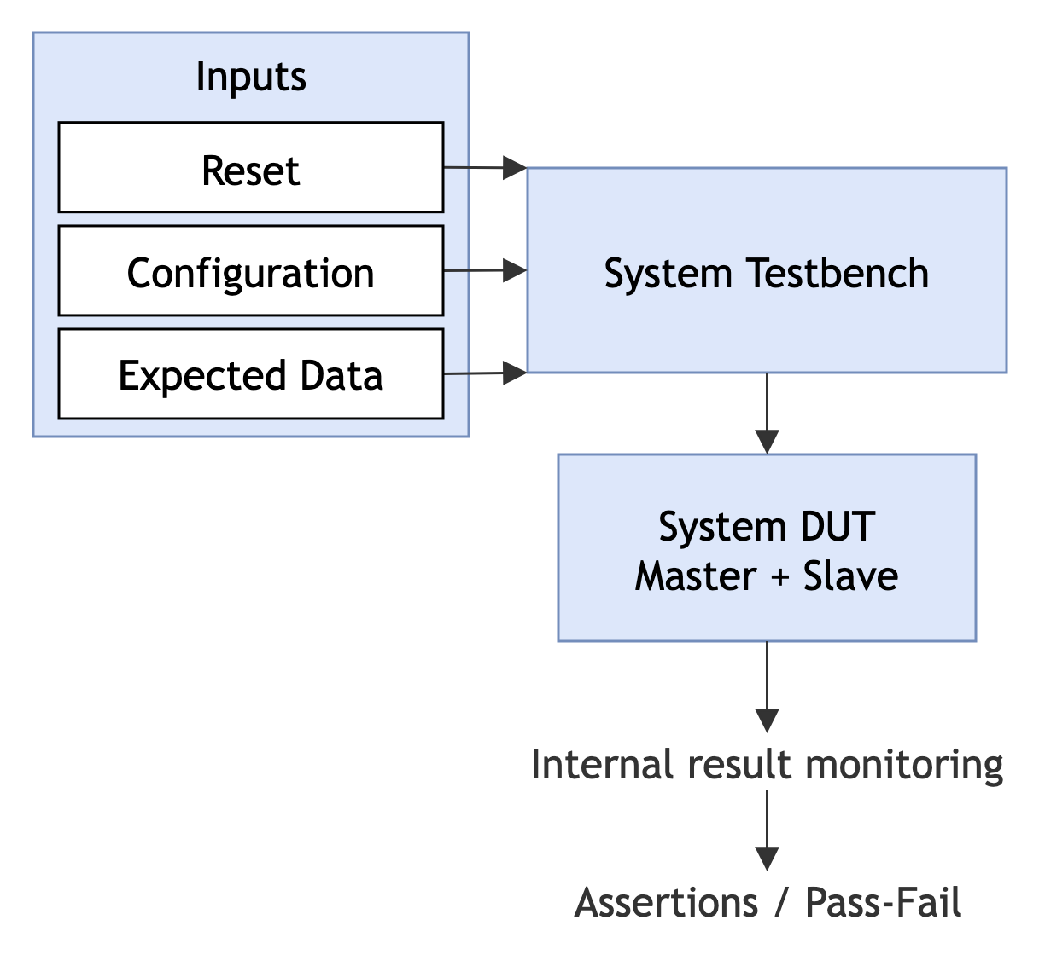

Waveform Examples

Single-byte read
Configurations: Mode 0, addr = 3, transfer length = 1, correct read data = h03.
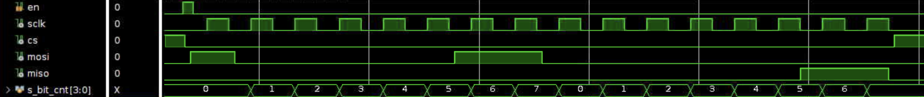

Single-byte write
Configurations: Mode 0, addr = 3, transfer length = 1, write data = h11.
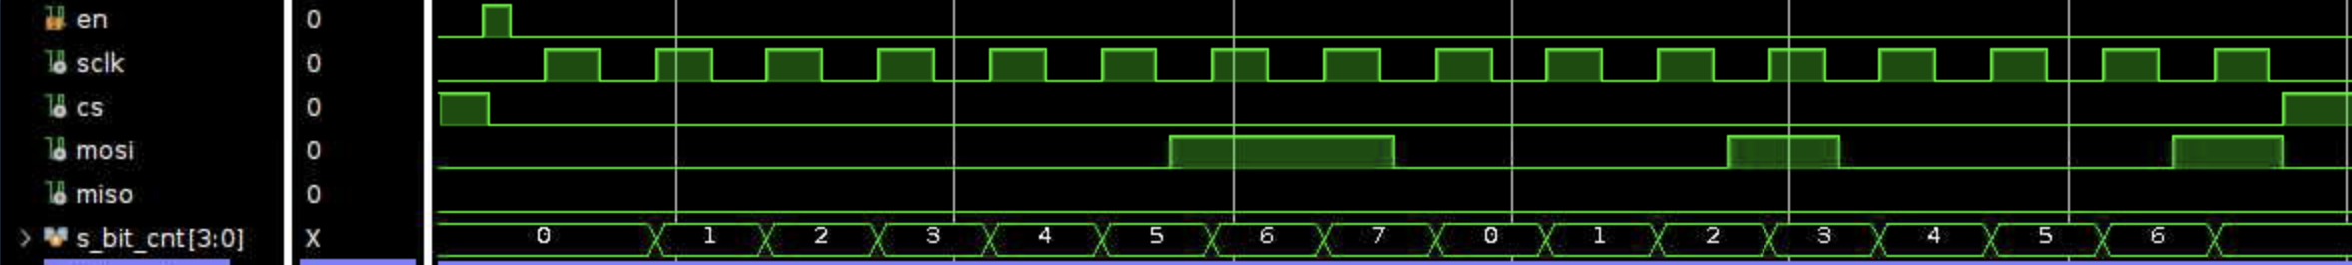

Multi-byte read
Configurations: Mode 0, addr = 3, transfer length = 3, correct read data = h030405.

Multi-byte write
Configurations: Mode 0, addr = 3, transfer length = 3, write data = h111111.

SPI Mode 0 – 3 Examples
All four examples show a 2-byte write transaction.
Mode 0

Mode 1
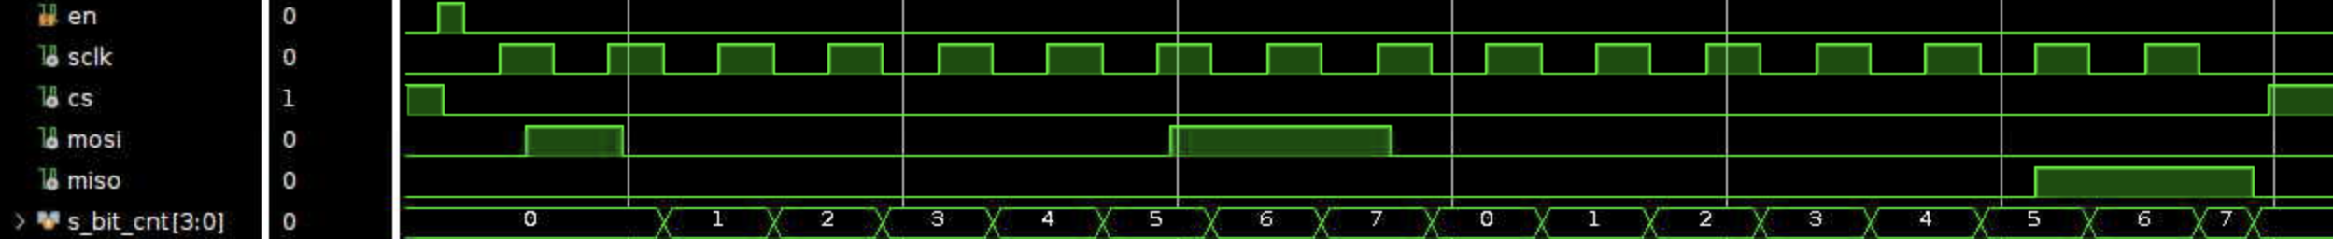
Mode 2
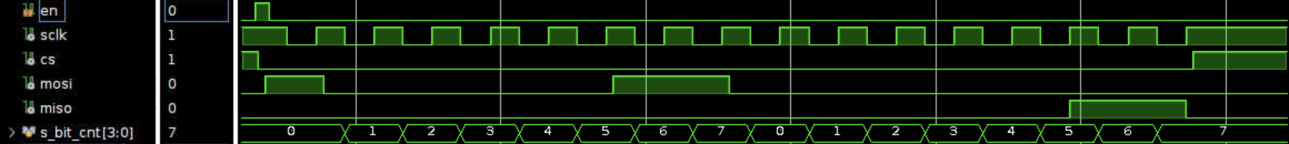
Mode 3

Conclusion
This project successfully implemented and verified a synthesizable SPI master and slave interface in Verilog. The design supports all four SPI modes, configurable clock division, 7-bit addressing, and single- or multi-byte read and write transactions. Through simulation and waveform analysis, the system was shown to correctly handle data transfer, address auto-increment, and mode-dependent clock timing. Overall, the project provided practical experience with RTL design, finite state machines, datapath organization, and digital verification.

